Binary Search

**Objec­tive :** Write an algo­rithm to find an ele­ment in an sorted array

**Input:** A sorted array, arrA[] and an key

**Out­put :** Return true if ele­ment is found, else false.

**Approach:** The idea is to com­pare the mid­dle ele­ment of array with the key, if key equal to the mid­dle ele­ment , that’s it you have find your ele­ment, return true. If key is greater than the mid­dle ele­ment, chuck out the first half of the array, you wont find your key in the first half and do the recur­sive search on the right half of the array and vice versa.

If(mid_element==key)

return true;

else if (mid>key)

do recursive search on the right half of the array.

else

do recursive search on the left half of the array.

**Time Com­plex­ity: O(logN)**–since we are elim­i­nat­ing half of the array with every comparison.

[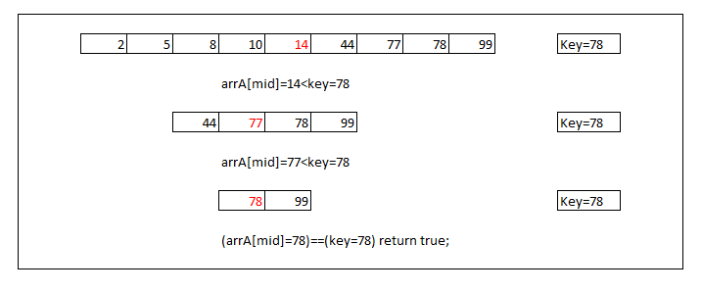](http://algorithms.tutorialhorizon.com/files/2014/07/Binary-Search1.png)

*Binary Search*